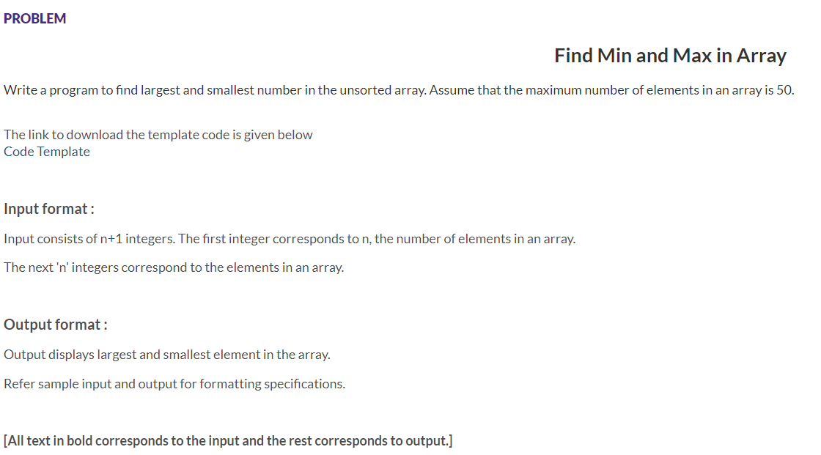

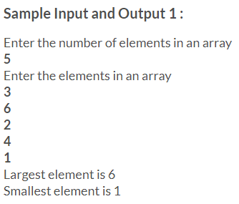

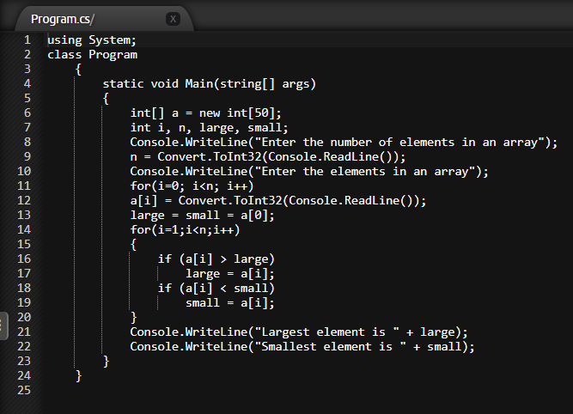

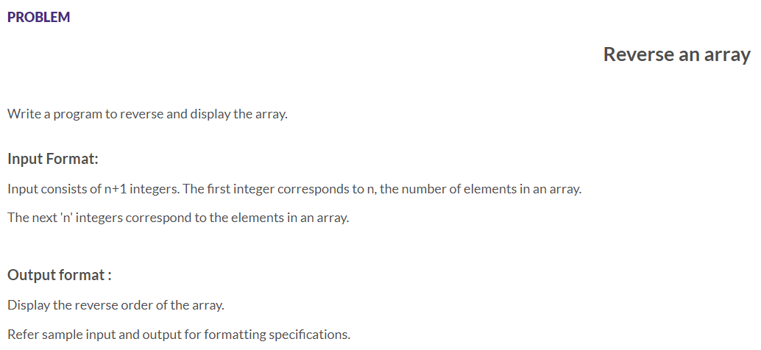

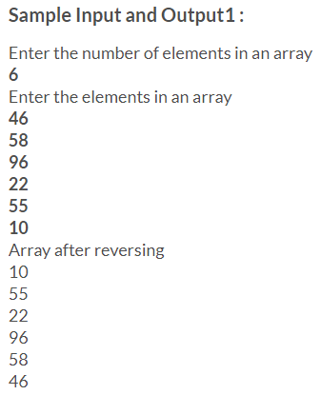

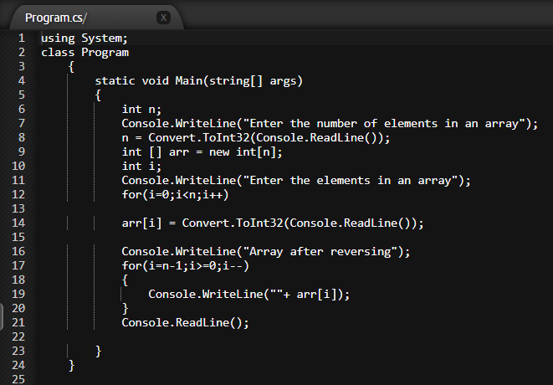

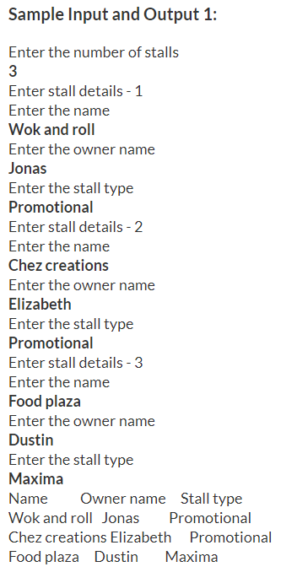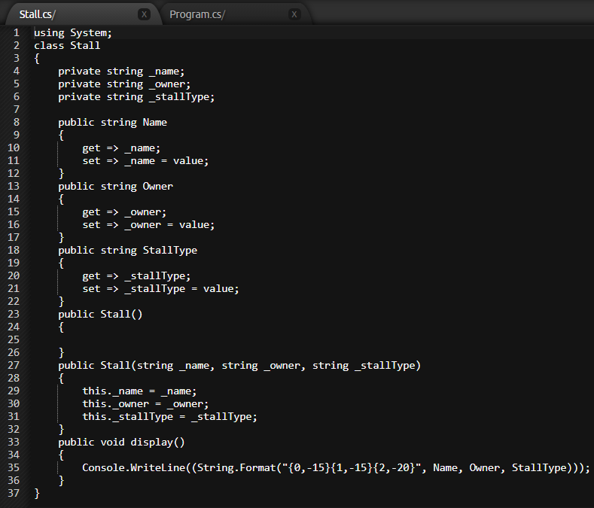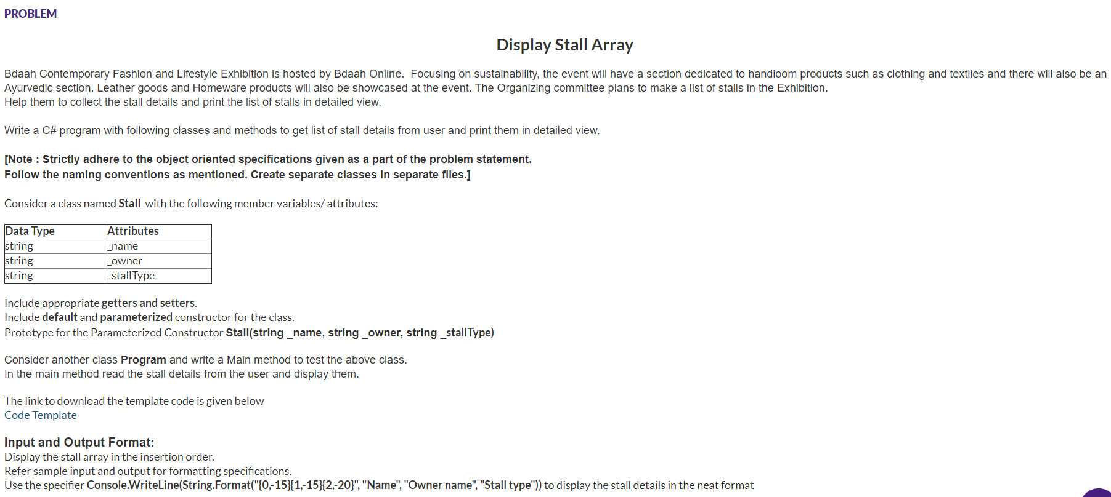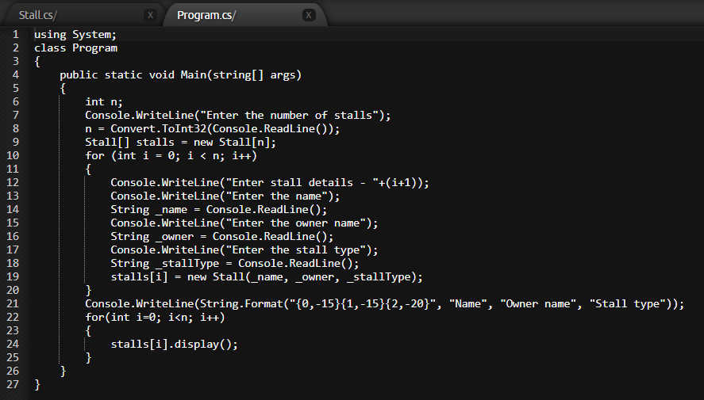

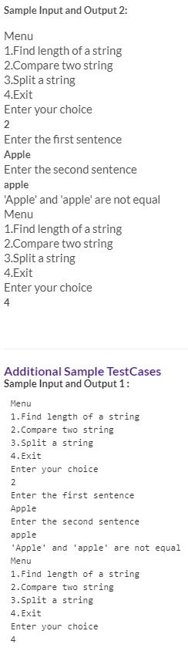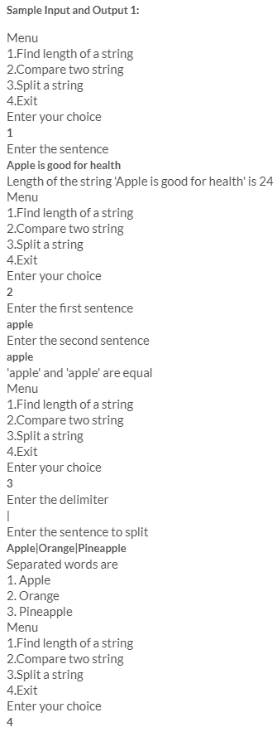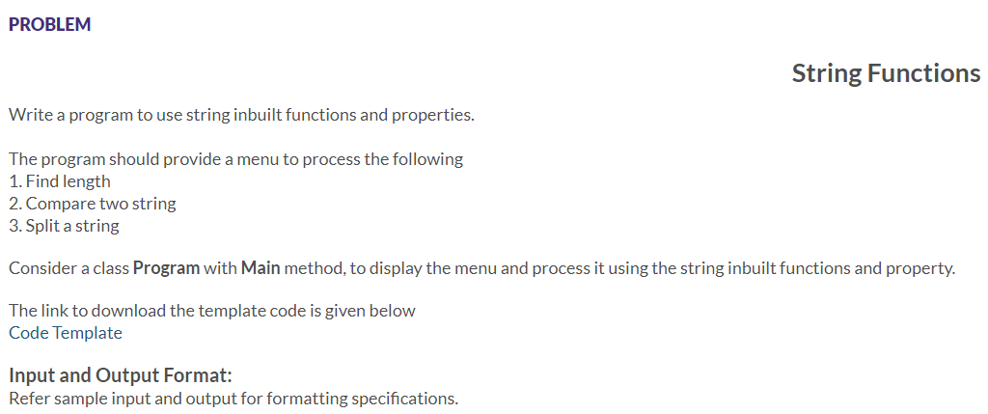

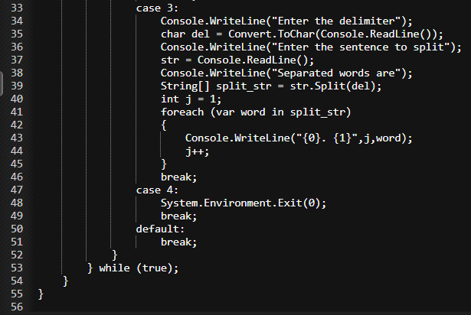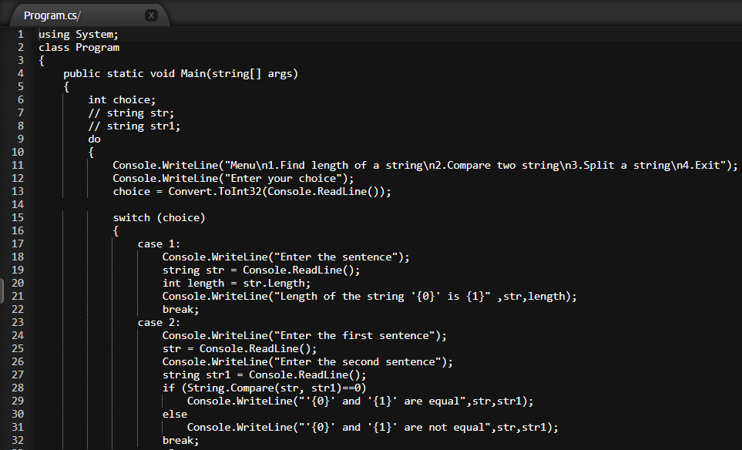

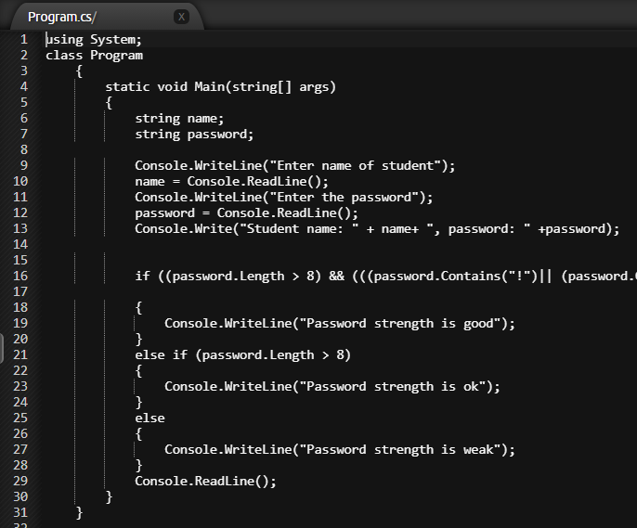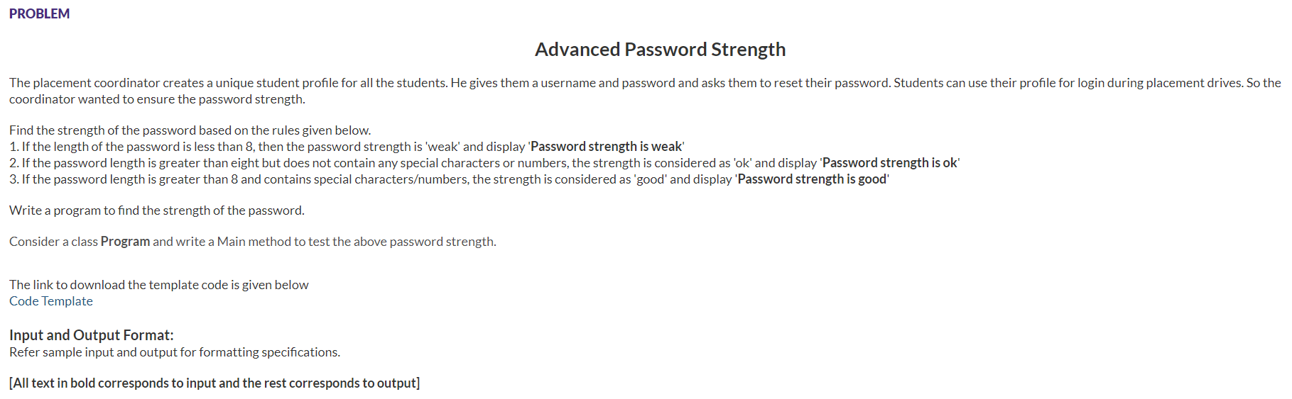

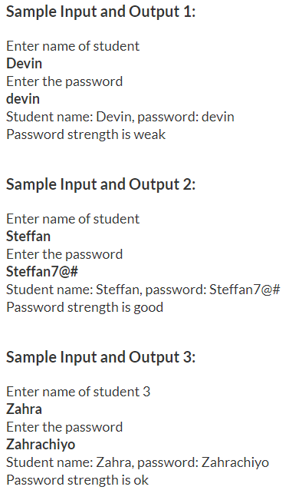

IF line

if ((password.Length > 8) && (((password.Contains("!")|| (password.Contains("@")||(password.Contains("#") || (password.Contains("$") || (password.Contains("%") || (password.Contains("^") || (password.Contains("&") || (password.Contains("\*") || (password.Contains("(") || (password.Contains(")") || (password.Contains("!") || (password.Contains("1") || (password.Contains("1") || (password.Contains("2") || (password.Contains("3") || (password.Contains("4") || (password.Contains("5") || (password.Contains("6") || (password.Contains("7") || (password.Contains("8") || (password.Contains("9") || (password.Contains("10")))))))))))))))))))))))))